Intro: why migrating?

Work on one table. Make one with a column on inches and convert it to cm by data migration.

The data migration is important, not the Db nor the tables.

Use SQL Developer and their tools.

Make a table with 10 entries, make it nice and easy.

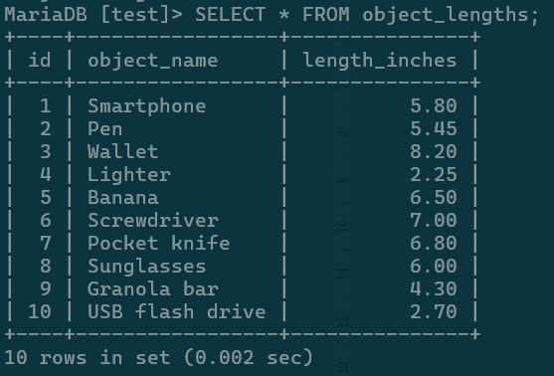

Table in question